90

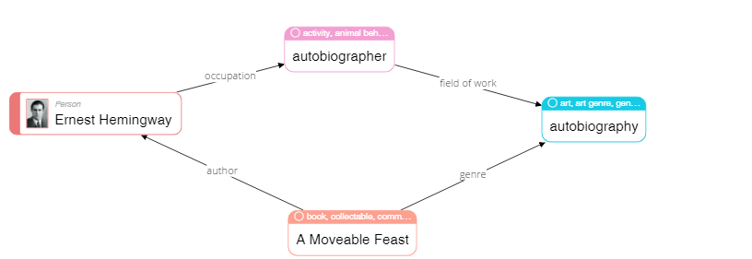

|  |
| --- |
| **Please describe shortly what you see on this diagram? Pay attention only to that information that is understandable or has sense for you.** |
| Topology of Ernest Hemingway activities |

68

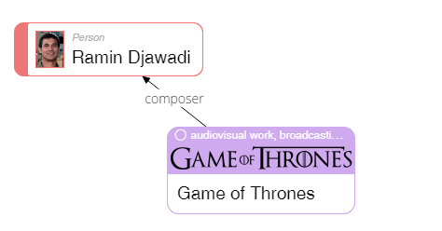

|  |
| --- |
| **Please describe shortly what you see on this diagram? Pay attention only to that information that is understandable or has sense for you.** |
| Ramin Djawadi is composer of the soundtrack of the series Game of Thrones |

23

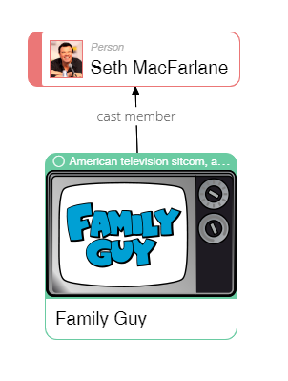

|  |
| --- |
| **Please describe shortly what you see on this diagram? Pay attention only to that information that is understandable or has sense for you.** |
| Seth MacFarlane is actor in the series Family Guy |

50

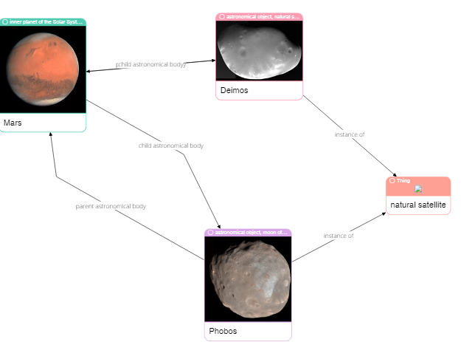

|  |
| --- |
| **Please describe shortly what you see on this diagram? Pay attention only to that information that is understandable or has sense for you.** |
| Interaction of various space objects such as The Phobos, The Mars and other |

62

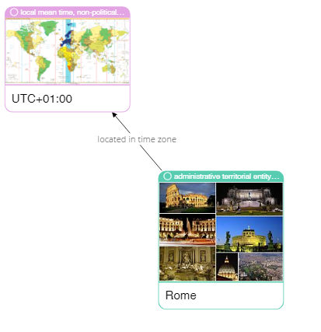

|  |
| --- |
| **Please describe shortly what you see on this diagram? Pay attention only to that information that is understandable or has sense for you.** |
| Time zone in Rome |

75

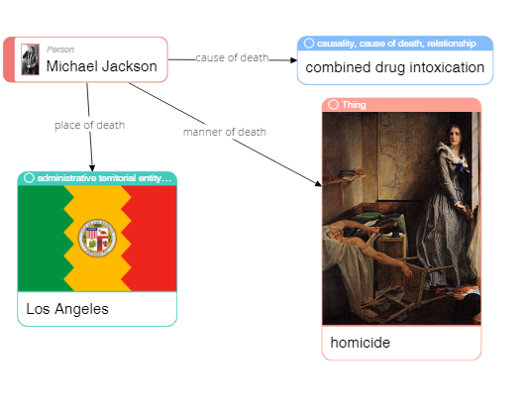

|  |
| --- |
| **Please describe shortly what you see on this diagram? Pay attention only to that information that is understandable or has sense for you.** |
| Facts about the death of Michael Jackson such as place of death is Los Angeles and cause of his death. |

79

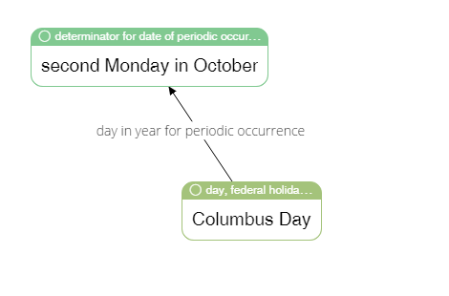

|  |
| --- |
| **Please describe shortly what you see on this diagram? Pay attention only to that information that is understandable or has sense for you.** |
| Periodicity of the Columbus Day’s in a year |

65

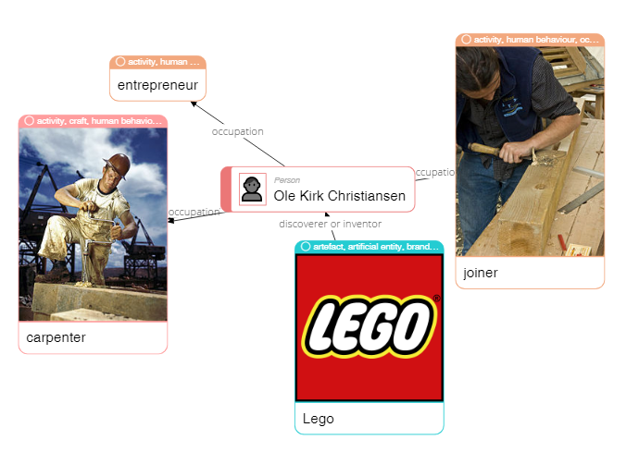

|  |
| --- |
| **Please describe shortly what you see on this diagram? Pay attention only to that information that is understandable or has sense for you.** |
| How Ole Kirk Christiansen appled your abilities for entrepreneurship Lego |

4

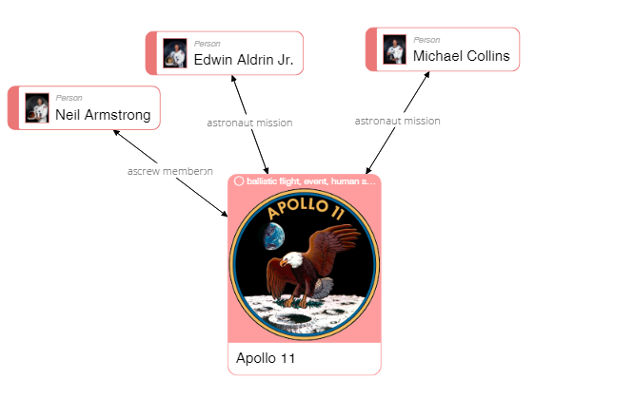

|  |
| --- |
| **Please describe shortly what you see on this diagram? Pay attention only to that information that is understandable or has sense for you.** |
| Team Apollo 11 who first landed on the moon |

40

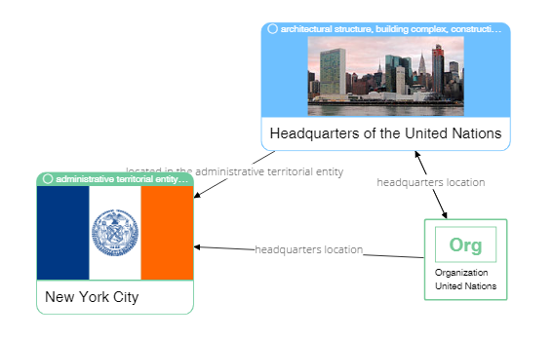

|  |
| --- |
| **Please describe shortly what you see on this diagram? Pay attention only to that information that is understandable or has sense for you.** |
| UN Location in the New York |

37

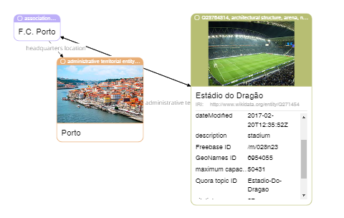

|  |
| --- |
| **Please describe shortly what you see on this diagram? Pay attention only to that information that is understandable or has sense for you.** |
| Photo info about location Porto and their stadium |